Python Teaching Resource
Python Teaching Resource

Week 1 - Print, Casting, String Manipulation, Syntax and Grammatical Errors, Variables and Constants, Selection (IF and CASE)
String Manipulation (slicing)
Week 2 - Single and Nested Loops
Week 3 - Single and Parallel Lists (1D)
Week 4 - Lists (2D)
Week 5 - Methods (Functions)
Week 6 - Standard Algorithms (Searching - Linear and Binary Search
Week 7 - Standard Algorithms (Sorting - Bubble and Selection Sort; Includes recursion and Quick Sort - HL)
Week 7 and 8 - Mini Project followed by Assessment?

Reference Guide
Primitive Data Types

Data Type | Description | Example
str | Sequence of characters (text) | name = "Alice"
int | Whole numbers without decimals | age = 16
float | Numbers with decimals | price = 4.99
bool | Logical values (True or False) | is_open = True

Mathematical Operators

Operator | Meaning | Example | Result
+ | Addition | total = 5 + 3 | 8
- | Subtraction | diff = 10 - 4 | 6
* | Multiplication | product = 6 * 2 | 12
/ | Division (float result) | result = 31 / 7 | 4.428
// | Integer (DIV) division | week = 31 // 7 | 4
% | Modulus (remainder) | day = 31 % 7 | 3
** | Exponentiation (square) | square = 5 ** 2 | 25

Casting

Function | Converts To | Accepts (common) | Example | Result | Notes/Pitfalls
int(x) | Integer | int, float, numeric str | int(3.9)  int("42") | 3  42 | Truncates toward 0 (not rounding).  int("3.5") → ValueError.
float(x) | Float | int, float, numeric str | float(7) | 7.0 | float("3.14") → 3.14.
str(x) | String | any object | str(5.6) | “5.6” | Uses object’s __str__.
bool(x) | Boolean | any object | bool(0) | False | Falsey: 0, 0.0, "", [], {}, set(), None. Everything else is True.

Common Debugging Techniques

Technique | Example code
try / except | 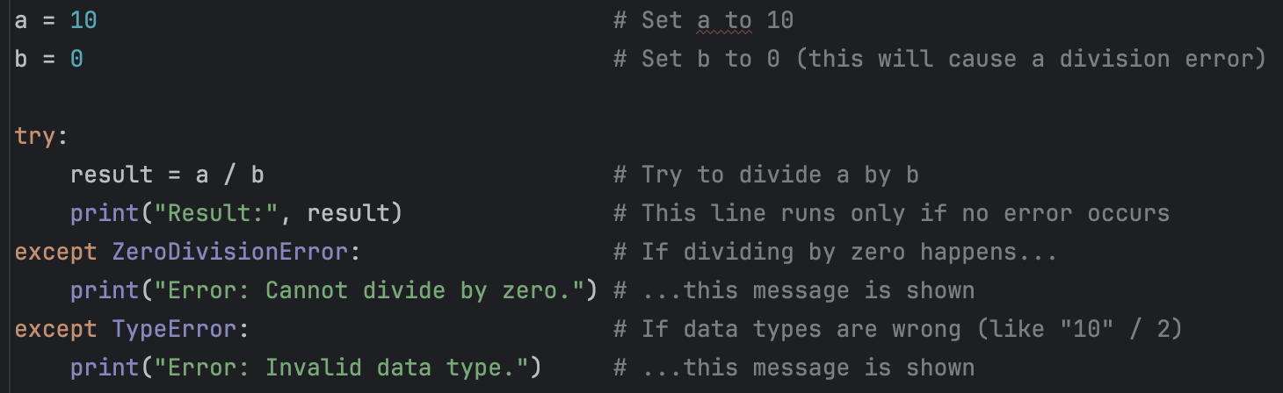
breakpoint() | 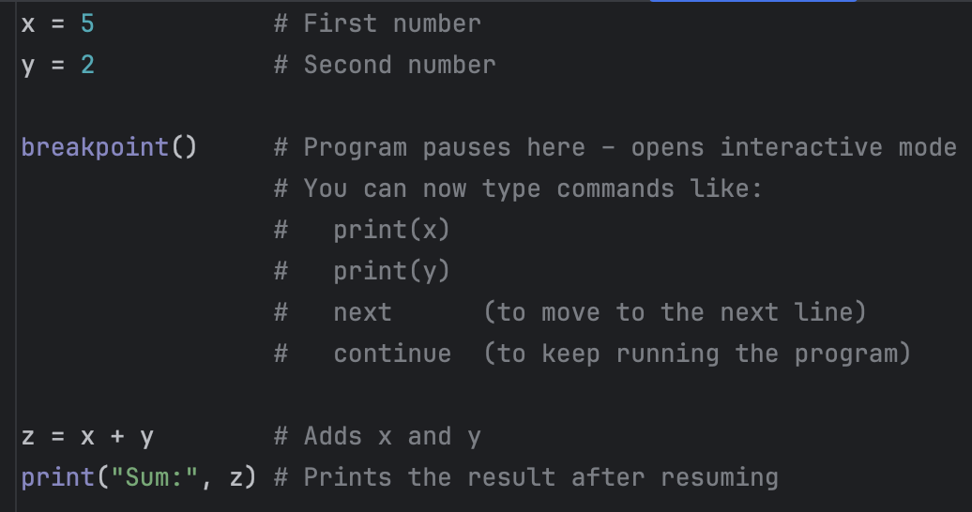 refer to the annotations within breakpoint, e.g. next

Python Libraries Overview

Library | What it’s for | Typical Import | Common things you can do | Example
random | Generate pseudorandom values | import random | integers, decimals, pick/shuffle items, set seed | random.randint(1, 6) → e.g. 4
os | Interact with the operating system | import os | list files, make folders, check paths | os.getcwd() → current folder path
datetime | Work with dates and times | from datetime import datetime, timedelta | current time, formatting, date math | datetime.now().strftime("%Y-%m-%d")
math | Mathematical functions & constants | import math | roots, trig, rounding, constants like π | math.sqrt(81) → 9.0

Week 1 - Introduction to Python
Week 1 - Introduction to Python

Teaching Concept | Example(s) | Description
String Manipulation (slicing) | 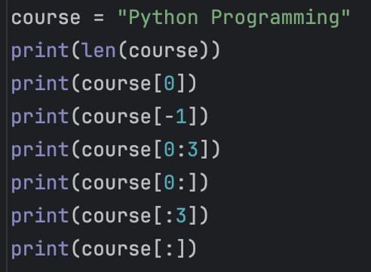
String Methods | 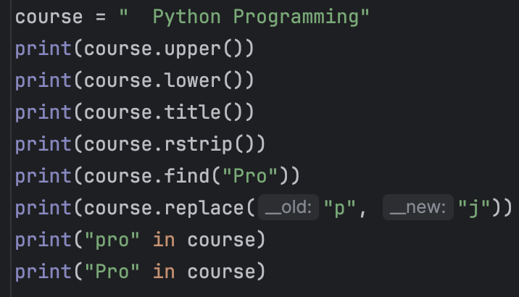 | .rstrip - removes spaces from right (.strip removes all space)  .find - finds the index of the string, returns -1 if not found
Format Output | 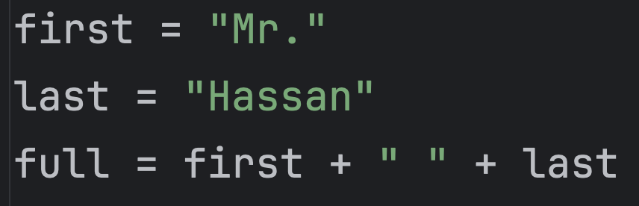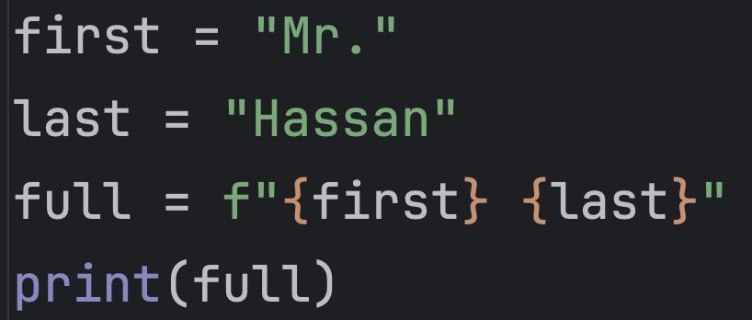 | \n - new line  Output 3dp - f"Item cost: {price:.3f}"  Include concatenation

Practice Questions

- A program stores a user’s name and age as text:
- The name may have extra spaces and random capitalisation.
- The age is stored as a string.

Write a program that:
- Removes the spaces and converts the name to title case.
- Converts the age to an integer.
- Prints whether the user is eligible to vote (18 or older).
- Includes the school name as a constant in the message.

# Start of code shared with students
SCHOOL_NAME = "St. Joseph's International"
raw_name = " aLeX "
age_str = "17"
# End of code shared with students

name = raw_name.strip().title()
age = int(age_str)

status = "eligible" if age >= 18 else "not eligible"
print(f"Welcome, {name}, to {SCHOOL_NAME}. You are {status} to vote.")


- Write a program that:
- Reads the price and quantity as strings.
- Converts them to numeric types.
- Calculates subtotal, 9% GST, and total.
- Adds free shipping if the total (after GST) is ≥ 50; otherwise adds 5 shipping.
- Prints all amounts to 2 decimal places.

GST_RATE = 0.09
FREE_SHIPPING_MIN = 50.00
price = input("Enter the price: ")
quantity = input("Enter the quantity of items bought: ")
price - float(price)
quantity = int(quantity)

subtotal = price * quantity
tax = subtotal * GST_RATE
total = subtotal + tax

if total >= FREE_SHIPPING_MIN:
shipping = 0.0
note = "Free shipping applied."
else:
shipping = 5.0
note = "Flat shipping added."

grand_total = total + shipping
print(f"Subtotal: {subtotal:.2f}")
print(f"GST (8%): {tax:.2f}")
print(f"Shipping: {shipping:.2f} — {note}")
print(f"Grand Total: {grand_total:.2f}")

- A student’s overall grade is calculated using three components: Quiz, Project, and Exam.
- The quiz is marked out of 20, the project out of 40, and the exam out of 100.
- Each component carries a different weight:
- Quiz = 20%
- Project = 30%
- Exam = 50%
- All scores are stored as strings and must be converted to numbers before calculation.
- The program should calculate the final weighted percentage and determine the letter grade based on the following boundaries:

Grade | Percentage Grade
A | >=85
B | >=70
C | >=55
D | >=40
E | <40

Write a Python program that:
- Converts all input scores from strings to numbers.
- Calculates the weighted average (as a percentage).
- Determines and prints the correct grade (A–E) based on the final score.
- Displays the final percentage and the grade in a single line.

A_MIN, B_MIN, C_MIN, D_MIN = 85, 70, 55, 40 # Ask students to enter values
quiz = int("18")
project = int("37")
exam = int("82") #

quiz_pct = (quiz / 20) * 100
project_pct = (project / 40) * 100
final = 0.2 * quiz_pct + 0.3 * project_pct + 0.5 * exam
if final >= A_MIN: grade = "A"
elif final >= B_MIN: grade = "B"
elif final >= C_MIN: grade = "C"
elif final >= D_MIN: grade = "D"
else: grade = "E"
print(f"Final: {final:.1f} → Grade {grade}")
Extension: How could we write this solution using a CASE statement instead of IF statements?

# Constants for grade boundaries
A_MIN, B_MIN, C_MIN, D_MIN = 85, 70, 55, 40

quiz_str, project_str, exam_str = "18", "37", "82" # Inputs as strings

# Casting to integers
quiz = int(quiz_str)
project = int(project_str)
exam = int(exam_str)

# Convert to percentages
quiz_pct = (quiz / 20) * 100
project_pct = (project / 40) * 100

# Weighted final score
final = 0.2 * quiz_pct + 0.3 * project_pct + 0.5 * exam

# Grade determination using match-case
match True:
case _ if final >= A_MIN:
grade = "A"
case _ if final >= B_MIN:
grade = "B"
case _ if final >= C_MIN:
grade = "C"
case _ if final >= D_MIN:
grade = "D"
case _:
grade = "E"

print(f"Final: {final:.1f} → Grade {grade}")


Week 2 - Iteration (Single and Nested Loops)
Week 2 - Iteration (Single and Nested)

While Loop

# Runs while the condition is True
while condition:
# code to execute
…

Example:
n = 3
while n > 0:
print(n)
n -= 1


For Loop

# Iterate over items in any iterable (list, string, range, etc.)
for item in iterable:
# code to execute each iteration
...

Example:
# Known number of repetitions
for i in range(5): # 0,1,2,3,4 - start from 0, not 1
print(i)

# Iterate over a collection
for name in ["Ana", "Ben", "Chen"]:
print(name)

# Prints every letter in “Hello” on a new line
word = "Hello"
for ch in word:
print(ch)



Practice Questions

- Write a program that uses a for loop to compute the sum of the first N natural numbers. Use N = 5. Print the final sum.

N = 5 # number of terms to sum: 1, 2, 3, 4, 5
total = 0 # accumulator variable starts at 0

# range(1, N+1) generates 1..5 (inclusive)
for i in range(1, N + 1):
total += i # add the current number i into the running total

print("Sum =", total) # final result


- Using a for loop, count how many vowels appear in the string word = "ComputerScience". Treat vowels as a, e, i, o, u (case-insensitive).

word = "ComputerScience"
vowels = "aeiou" # reference set of vowels (lowercase)
count = 0 # accumulator for how many vowels we find

# Convert whole word to lowercase so 'E' and 'e' are treated the same
for ch in word.lower():
if ch in vowels: # membership test: is this character a vowel?
count += 1 # increment the counter

print("Vowel count =", count)

- Write a while loop that counts down from start = 5 to 1, printing each number on its own line, then prints "Liftoff!".

start = 5 # starting value for the countdown

# Continue looping while start is at least 1
while start >= 1:
print(start) # show the current number
start -= 1 # decrease by 1 each iteration

print("Liftoff!") # message after the loop ends


- Use a while loop to compute the factorial of n = 6. Print the result in the form 6! = 720.

n = 6
i = 1 # loop counter starting at 1
fact = 1 # factorial accumulator (multiplicative identity = 1)

# Keep multiplying by i while i <= n
while i <= n:
fact *= i # same as: fact = fact * i
i += 1 # move to the next integer

print(f"{n} factorial = {fact}")

- Use nested for loops to print a 3×4 multiplication table (rows = 1..3, columns = 1..4). Print each row on one line with spaces between numbers.

# Outer loop: rows 1..3
for r in range(1, 4):
line = "" # build a text line for this row
# Inner loop: columns 1..4
for c in range(1, 5):
line += str(r * c) + " " # append product and a space
#print(line.strip()) # strip trailing space for neatness
print(line)


- Using nested while loops, print a triangle of * with rows = 4 like:

*
**
***
****

rows = 4
r = 1 # current row

while r <= rows: # outer loop controls the row number
c = 1 # reset the star counter for each row
line = ""
while c <= r: # inner loop adds r stars on row r
line += "*" # add an additional *
c += 1
print(line)
r += 1


- Use a for loop to iterate through a range of values a user enters.
For each base, use a while loop to print the first three multiples of that base (no arrays/lists and no string multiplication).

Example:
Enter start of range: 2
Enter end of range: 4
2: 2 4 6
3: 3 6 9
4: 4 8 12

# Read and cast user inputs
start = int(input("Enter start of range: "))
end = int(input("Enter end of range: "))

# Outer loop: iterate bases from start to end, inclusive
for base in range(start, end + 1):
print(f"{base}:", end=" ") # label the line
k = 1 # multiplier starts at 1

# Inner loop: print first three multiples for this base
while k <= 3:
product = base * k
print(product, end=" ")
k += 1 # move to next multiple

print() # newline after finishing this base


Week 3 - Single and Parallel Lists (1D)
Week 3 - Single and Parallel Lists (1D)
A list is an ordered collection of items (usually of the same logical type) stored in a single structure.
Use it to keep things like numbers, names, or scores together.
- Indexing starts at 0 and goes up to len(list) - 1.
- Lists are mutable (you can change, add, or remove items).
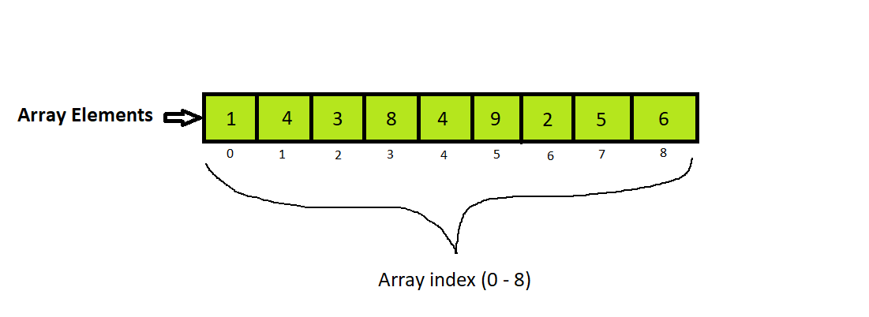

scores = [] # empty list
scores = [0] * 5 # [0, 0, 0, 0, 0]
scores = [85, 90, 78, 92, 88] # Initialise values in a list
numbers = [1, 2, 3]
print(numbers[3]) # IndexError: list index out of range (valid: 0..2)


Common List Methods

Method/Operation | What it Does | Example | Result/Notes
append(x) | Add one item to the end | scores.append(95) | [85, 90, 78, 92, 88, 95]
insert(i, x) | Insert item at position i | scores.insert(2, 70) | [85, 90, 70, 78, 92, 88]
remove(x) | Remove first matching item | scores.remove(90) | [85, 70, 78, 92, 88]
pop([i]) | Remove & return last item (or index i) | scores.pop() | returns 88
clear() | Remove all items | scores.clear() | []

Note - There are many more list methods in Python.
However, for IB Computer Science exam purposes, you are expected to demonstrate standard algorithms (such as adding, deleting, searching, and sorting) by coding them manually rather than relying solely on built-in methods.

Practice Questions

- Given a list scores = [12, 19, 7, 14, 18], calculate and print the sum and average (to 1 decimal place) without using sum().

scores = [12, 19, 7, 14, 18]
total = 0
for i in range(len(scores)):
total += scores[i]

avg = total / len(scores)
print("Sum =", total)
print(f"Average = {avg:.1f}")


- Write a program that finds and prints:
- the lowest temperature, and
- the index position where it occurs.

temps = [] # initialise list
for i in range(5):
value = int(input("Enter a number: "))
temps.append(value)
lowest = temps[0] # start with the first value
position = 0 # assume lowest is at index 0
for i in range(1, len(temps)): # start comparing from index 1
if temps[i] < lowest: # found a new lower value
lowest = temps[i]
position = i # record where it was found
print("Lowest temperature:", lowest)
print("Found at index:", position+1)

- Given parallel lists:
names = ["Ava", "Ben", "Chen", "Dia"]
scores = [ 72, 85, 85, 64 ]

Print each pair as Name -> Score.
Find and print the highest score and all names who achieved it (handle ties).

# Parallel lists: each index i refers to the same student across both lists
names = ["Ava", "Ben", "Chen", "Dia"]
scores = [72, 85, 85, 64]

# 1) Print each name with its matching score (use the same index in both lists)
for i in range(len(names)): # i goes 0,1,2,3
print(names[i], "->", scores[i]) # e.g., names[1] with scores[1]

# 2) Find the highest score manually (no built-ins like max())
highest = scores[0] # start by assuming first score is the highest
for i in range(1, len(scores)): # compare from the second item onwards
if scores[i] > highest: # found a new higher score?
highest = scores[i] # update the current highest

# 3) Print the highest score and all names who achieved it (handle ties)
print("Highest score:", highest)
print("Top students:")
for i in range(len(scores)):
if scores[i] == highest: # if this student's score matches the highest
print("-", names[i]) # print the corresponding name
- Using

products = ["Pen", "Notebook", "Folder", "Marker"]
prices = [ 1.50, 3.20, 2.80, 4.00 ]

Apply a rule: reduce price by 10% for any item with price ≥ 3.00.
Print each line as Product: old_price -> new_price.

# Parallel lists: same index i links a product to its price
products = ["Pen", "Notebook", "Folder", "Marker"]
prices = [1.50, 3.20, 2.80, 4.00]

# Loop over all positions (0..len-1)
for i in range(len(products)):
old_price = prices[i] # get the current item's price

# Apply 10% discount if price is >= 3.00
if old_price >= 3.00:
new_price = old_price * 0.90 # 10% off → keep 90%
else:
new_price = old_price # no change

# Print product name and prices rounded to 2 d.p.
print(products[i] + ":", round(old_price, 2), " ", round(new_price, 2))


Week 4 - 2D Lists
Week 4 - 2D Lists

A 2D list is a list where each element is another list.

Use it to model tables, grids, or matrices (e.g., rows × columns).

- Indexing still starts at 0.
- Access items as matrix[row][col].
- 2D lists are mutable (you can change cells, rows, etc.).
- Rows can be equal length (rectangular) or not (ragged).

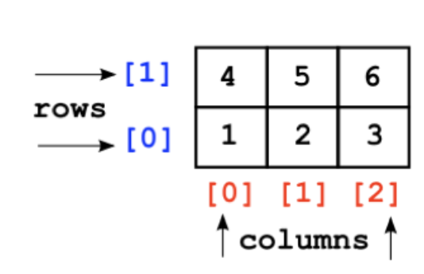

# Empty 2D list
grid = []

# 2×3 zero matrix (SAFE approach)
rows = 2
cols = 3
grid = [[0 for _ in range(cols)] for _ in range(rows)]
# grid -> [[0, 0, 0],
# [0, 0, 0]]

# output values in the 2D list
for i in range(rows):
print()
for j in range(cols):
print(grid[i][j], end=" ")

# Initialise with values (3 rows × 3 cols)
marks = [
[85, 90, 78],
[92, 88, 81],
[76, 84, 89]
]

# Insert values in 2D list
# Input values into the 2D array (2 rows x 3 columns)
for row in range(2): # row 0 and 1
row_list = []
for column in range(3): # column 0, 1, 2
value = int(input("Enter number: "))
row_list.append(value)
grid.append(row_list)


Practice Question

Ask the user to enter values into a 4 x 3 matrix (2D list) of integer numbers, find the highest value and print all (row, columns) positions where it appears.

# Dimensions
rows = 4
columns = 3

# 1) Build the 2D list by reading integers from the user
grid = [] # will become a list of 4 rows
for row in range(rows): # row = 0..3
row_list = [] # build one row at a time
for column in range(columns): # column = 0..2
value = int(input(f"Enter value at (row {row}, columns {column}): "))
row_list.append(value) # add this cell to the current row
grid.append(row_list) # add the completed row to the grid

# 2) Find the highest value manually (no max())
highest = grid[0][0] # start with the first cell
for row in range(rows): # scan all rows
for column in range(columns): # scan all columns in this row
if grid[row][column] > highest:
highest = grid[row][column] # update when a larger value is found

# 3) Print every (row, columns) where the cell equals the highest value (tie-aware)
print("Highest value:", highest)
print("Positions (row, columns):")
for row in range(rows):
for column in range(columns):
if grid[row][column] == highest:
print("(", row+1, ",", column+1, ")")


Week 5 - Methods (Functions)
Week 5 - Methods (Functions)

A function is a named block of code that performs one specific task.
You can define it once and reuse it many times in a program.

Functions make programs easier to read, test, and update, just like using modules in larger systems.

# Function to calculate area of a rectangle
def rectangle_area(length, width):
area = length * width
return area

# Function to display the result
def show_result(length, width):
print("Area:", rectangle_area(length, width))

# Main program
show_result(5, 3)


Advantages of functions:

- Code is easier to read:
  - Breaking a program into smaller functions lets you see what each part does.
  - Each function has a clear name and purpose, which makes programs easier to understand.
- Code is easier to test:
  - You can test each function independently before running the whole program.
  - If something doesn’t work, you know exactly which part to fix.
- Code is easier to reuse:
  - Functions can be copied or imported into new programs.
  - This saves time when solving similar problems or using the same logic again.
- Code is easier to update:
  - When code is separated into functions, only that function needs to be changed; the rest of the program stays the same.

Practice Questions

- Ask the user how many marks there are, then read that many integer marks into a 1D list. Write a function update_list(scores) that adds +5 to every mark but caps the result at 100. Update the list in place, then print the updated marks on one line, space-separated.

def update_list(scores):
"""
Add +5 to each mark, with a maximum of 100.
Mutates the list 'scores' in place.
"""
for i in range(len(scores)): # loop by index so we can assign back
new_val = scores[i] + 5
if new_val > 100: # cap at 100
new_val = 100
scores[i] = new_val # write back to the same position

# --- Input phase ---
n = int(input("How many marks? "))
scores = []
for i in range(n):
mark = int(input(f"Enter mark {i+1}: "))
scores.append(mark)

# --- Curve and output ---
update_list(scores)

# Print updated list in one line
line = ""
for i in range(len(scores)):
if i > 0:
line += " "
line += str(scores[i])
print(line)

Challenge: Ask the user to enter integer marks for a 3 rows × 4 columns table (3 students, 4 tests). Write a function update_table(grid) that adds +5 to every value but caps the result at 100. Update the table in place, then print the updated table row by row.

def update_table(grid):
"""
Add +5 to every cell but cap at 100.
Mutates the 2D list in place using rows and columns loops.
"""
rows = len(grid)
columns = len(grid[0])
for row in range(rows):
for column in range(columns):
new_value = grid[row][column] + 5
if new_value > 100: # cap
new_value = 100
grid[row][column] = new_value # write back

# --- Input 3x4 grid from user ---
rows, columns = 1, 2
marks = []
for row in range(rows):
row_list = []
for column in range(columns):
val = int(input(f"Enter mark at (row {row}, columns {column}): "))
row_list.append(val)
marks.append(row_list)

# --- update and print ---
update_table(marks)

print("Updated Table:")
for row in range(rows):
line = ""
for column in range(columns):
line += str(marks[row][column]) + " "
print(line.strip()) # removes leading/trailing whitespace before printing


- Ask the user for n, then read n integers into a 1D list. Write a function is_palindrome(values) that returns True if the list reads the same forward and backward, otherwise False. Print the result.

def is_palindrome(values): # Define a function that checks if a list reads the same forwards/backwards.
"""
Return True if values is the same forwards and backwards.
Standard two-pointer check: left and right move towards the center.
""" # Docstring: explains purpose and method (two-pointer technique).
left, right = 0, len(values) - 1 # Initialize two indices: left at start, right at end of the list.
while left < right: # Loop until the pointers cross (no need to check the middle twice).
if values[left] != values[right]: # If a mirrored pair differs, it's not a palindrome…
return False # …so we can immediately return False (early exit).
left += 1 # Move left pointer one step to the right.
right -= 1 # Move right pointer one step to the left.
return True # If all mirrored pairs matched, the list is a palindrome.

# --- Input 1D list from user ---
n = int(input("How many numbers? ")) # Ask how many numbers; convert the input string to an int.
nums = [] # Start with an empty list to collect user numbers.
for i in range(n): # Repeat exactly n times to gather all inputs.
nums.append(int(input(f"Enter number {i+1}: "))) # Prompt for each number, convert to int, append to the list.

# --- Use the function ---
print("Palindrome?", is_palindrome(nums)) # Call the function with the collected list and print True/False.


Week 6 - Searching Algorithms
Week 6 - Searching Algorithms

A searching algorithm helps you find a specific item or value within a list or collection. A sorting algorithm arranges data into a particular order, such as smallest to largest or alphabetically.

These algorithms make it easier and faster to work with data, especially when the data grows large. They are the foundation of how computers look up information efficiently.

Why we need them:
- Searching and sorting are core operations in most programs, from finding a student’s mark in a list to ranking scores or organising data before analysis.
- Well-chosen algorithms can make a program run faster and use less memory.
- Understanding them helps programmers choose the right method for the situation.

Linear Search

Linear Search (also called Sequential Search) checks each item in the list one by one until it finds the target or reaches the end.

Advantages:
- Simple to understand and implement
- Works on unsorted lists
- Good for small datasets

Disadvantages:
- Can be slow for large lists (must check every item)
- Efficiency: O(n) — time increases linearly with list size

# A simple list (1D) of song titles
playlist = ["Hidden River", "Star Trails", "Autumn Echoes",
"Neon Skyline", "Paper Planes", "Silent Horizon"]

foundIndex = -1 # sentinel value meaning "not found" (valid indexes are 0..len-1)

# Ask the user what to search for
searchTerm = input("What song are you looking for? ")

# Linear search: check each item one by one
for name in playlist:
if name == searchTerm: # exact, case-sensitive match
# Get the index of the matching item in the list
foundIndex = playlist.index(name) # e.g., 0 for first item
break # stop after the first match (optional)
# Report the result using the sentinel
if foundIndex != -1:
print("The song was found at " + str(foundIndex))
else:
print("The song was not found")

Binary Search

Binary Search works on a sorted list. It repeatedly checks the middle item to decide whether to look in the left half or the right half, cutting the search space in half each step.

Advantages:
- Much faster than linear search on large sorted lists (keeps halving the search space)
- Time complexity: O(log n)

Disadvantages:
- Requires a sorted list (you must sort first if the data isn’t sorted)
- Slightly more complex to implement and reason about off-by-one boundaries

def binarySearch(searchArray, left, right, searchTerm):
"""
Return the index of searchTerm in searchArray using binary search,
or -1 if it is not found.
Requires: searchArray is sorted in ascending order.
left = starting index to search (usually 0)
right = ending index to search (usually len(searchArray) - 1)
"""
# Keep searching while there is a valid window [left..right]
while left <= right:
# Middle index (safe formula avoids overflow in some languages)
midPoint = left + (right - left) // 2

# If the middle element is exactly the target, we're done
if searchArray[midPoint] == searchTerm:
return midPoint

# If target is greater than middle value, ignore the LEFT half
elif searchArray[midPoint] < searchTerm:
left = midPoint + 1

# Otherwise target is smaller than middle value: ignore the RIGHT half
else:
right = midPoint - 1

# If we exit the loop, the item was not found
return -1

# --- Example dataset (sorted) ---
productCodes = [102, 118, 130, 147, 155, 162, 174, 189, 205]

# What are we looking for?
searchTerm = 162

# Call binary search over the full range (0..len-1)
result = binarySearch(productCodes, 0, len(productCodes) - 1, searchTerm)

# Report
if result != -1:
print("Product code", searchTerm, "found at index", result)
else:
print("Product code", searchTerm, "not found")

Practice Questions

- Ask the user how many integers there are, then read that many values into a 1D list. Write a function linear_search_1d(values, target) that scans the entire list and prints all index positions where the target is found. If there are no matches, print “Target not found.”

def linear_search_1d(values, target):
"""
Scan every element in the 1D list 'values'.
Print all index positions where values[index] == target.
Works for UNSORTED data (plain linear search).
"""
found_any = False
# Go through each position by index so we can print the index directly
for index in range(len(values)):
if values[index] == target: # exact match?
print("Found at index", index)
found_any = True

if not found_any:
print("Target not found.")

# -------- Input phase --------
n = int(input("How many numbers? "))

# Build the 1D list of integers from user input
values = []
for i in range(n):
num = int(input(f"Enter number {i+1}: "))
values.append(num)

target = int(input("Enter the number to search for: "))
# -------- Search & output --------
linear_search_1d(values, target)

Challenge: Ask the user to enter the number of rows and columns for a 2D list of integers. Then ask them to enter each value. Write a function linear_search_2d(grid, target) that scans the entire 2D list and prints all (row, columns) positions where the target is found.

def linear_search_2d(grid, target):
"""
Scan each row and columns to find all occurrences of 'target'.
Works on unsorted 2D lists.
Returns a list of (row, columns) positions.
"""
positions = []
for row in range(len(grid)): # loop through rows
for columns in range(len(grid[row])): # loop through columns in each row
if grid[row][columns] == target: # check if this cell matches
positions.append((row, columns))
return positions

# --- Input phase ---
rows = int(input("Enter number of rows: "))
columns = int(input("Enter number of columns: "))

grid = []
for row in range(rows):
row_list = []
for col in range(columns):
value = int(input(f"Enter value for (row {row}, columns {col}): "))
row_list.append(value)
grid.append(row_list)

target = int(input("Enter the number to search for: "))

# --- Search and output phase ---
found_positions = linear_search_2d(grid, target)

if found_positions:
print("Value found at positions:", found_positions)
else:
print("Value not found.")


- Ask the user how many numbers there are, then read that many integers into a sorted (ascending) 1D list. Write a function binary_search(values, target) that returns the index of target in the list (or -1 if not found). Finally, print the result.

def binary_search(values, target):
"""
Return the index of target in the sorted 1D list 'values',
or -1 if target is not present.
Assumes 'values' is sorted in ascending order.
"""
left = 0
right = len(values) - 1

# Keep a valid search window [left .. right]
while left <= right:
mid = left + (right - left) // 2 # middle index
mid_val = values[mid]

if mid_val == target: # found it
return mid
elif mid_val < target: # target is in the RIGHT half
left = mid + 1
else: # target is in the LEFT half
right = mid - 1

return -1 # not found

# ---- Input phase ----
n = int(input("How many numbers? "))
print("Enter the numbers in **ascending** order:")

nums = []
for i in range(n):
val = int(input(f"Number {i+1}: "))
nums.append(val)

x = int(input("Enter the number to search for: "))

# ---- Search and report ----
pos = binary_search(nums, x)

if pos != -1:
print(f"{x} found at index {pos}")
else:
print(f"{x} not found")


Week 7 - Sorting Algorithms
Week 7 - Sorting Algorithms

A sorting algorithm arranges items in a list into a specific order, for example, from smallest to largest, or alphabetically from A to Z.

Sorting helps make data easier to read, search, and analyse. Once data is sorted, it becomes much faster to locate specific items, perform comparisons, or display information neatly (like ranking exam scores or listing products by price).

Why We Need Them
- Organisation: Sorted data is easier to understand and process.
- Efficiency: Many tasks (like searching or reporting) become faster after sorting.
- Foundation for other algorithms: Sorting is often a first step before applying more complex operations such as searching or data analysis.
- Real-world relevance: From sorting names in a school database to ordering search results online, sorting algorithms power countless everyday systems.

Bubble Sort

Bubble Sort repeatedly compares adjacent elements and swaps them if they are in the wrong order. This continues until no swaps are needed, meaning the list is sorted.

Advantages:
- Easy to understand and code
- Useful for teaching how sorting works step by step

Disadvantages:
- Inefficient for large lists (many repeated comparisons)
- Efficiency: O(n²) — time grows quickly as list size increases

# Dataset (different from the screenshot): unsorted daily sales numbers
toSort = [42, 7, 19, 3, 12, 5, 19, 33]

# Bubble Sort:
# Repeatedly compare adjacent items and swap if they are in the wrong order.
# After each outer pass i, the largest unsorted value "bubbles" to the end.

for i in range(0, len(toSort)): # number of passes
# Inner loop goes up to the last unsorted position (len-1-i)
for j in range(0, len(toSort) - i - 1): # adjacent comparisons
if toSort[j] > toSort[j + 1]: # out of order?
# Swap the two adjacent items
temp = toSort[j]
toSort[j] = toSort[j + 1]
toSort[j + 1] = temp

print(toSort) # final sorted list (ascending)

Selection Sort

Selection Sort repeatedly selects the smallest (or largest) item from the unsorted part of the list and swaps it into the next position of the sorted part.

Advantages:
- Simple to understand and implement
- In-place (no extra list needed)
- Makes at most n−1 swaps → useful when swaps are expensive

Disadvantages:
- Always does about n²/2 comparisons (slow on big lists), even if nearly sorted
- Not stable without extra work (equal items can change relative order)
- Time complexity: O(n²)

# Dataset (different from your screenshot): unsorted ages
toSort = [73, 15, 88, 21, 42, 60, 9, 37]

# Selection Sort (ascending):
# For each position i, find the SMALLEST value in the range [i..end)
# and swap it into position i.

for i in range(0, len(toSort) - 1): # i marks the start of the unsorted region
highestIndex = i # (name from the original code)
# NOTE: despite the name, we are actually tracking the index of the *smallest*
# value because of the '<' comparison below.

# Scan the rest of the (unsorted) list to find the smallest value's index
for j in range(i + 1, len(toSort)):
if toSort[j] < toSort[highestIndex]: # found a new minimum?
highestIndex = j # remember its position

# Swap the smallest found value into position i
temp = toSort[highestIndex]
toSort[highestIndex] = toSort[i]
toSort[i] = temp

print(toSort) # final sorted list (ascending)

Practice Questions

- Ask the user for n integers and store them in a list.
- Bubble sort the list in ascending order.
- Ask for a target value and use binary search to find its index (or report not found).
- Print the sorted list and the search result.

# -------- Bubble Sort + Binary Search --------
def bubble_sort(values):
"""
In-place bubble sort (ascending).
Repeatedly compare adjacent items and swap if out of order.
After each outer pass, the largest remaining item 'bubbles' to the end.
"""
n = len(values)
for i in range(n): # number of passes
for j in range(0, n - 1 - i): # compare up to last unsorted
if values[j] > values[j + 1]: # wrong order? swap
temp = values[j]
values[j] = values[j + 1]
values[j + 1] = temp

def binary_search(values, target):
"""
Standard binary search on a sorted (ascending) list.
Returns the index if found, else -1.
"""
left = 0
right = len(values) - 1
while left <= right: # valid search window
mid = left + (right - left) // 2 # middle index
if values[mid] == target:
return mid
elif values[mid] < target: # look in right half
left = mid + 1
else: # look in left half
right = mid - 1
return -1

# ---- Input phase ----
n = int(input("How many numbers? "))
nums = []
for i in range(n):
nums.append(int(input(f"Enter number {i+1}: ")))

# ---- Sort then search ----
bubble_sort(nums)
print("Sorted list (bubble):", nums)

x = int(input("Enter a value to binary-search: "))
pos = binary_search(nums, x)

if pos != -1:
print(f"{x} found at index {pos}")
else:
print(f"{x} not found")

- Ask the user for m integers and store them in a list.
- Selection sort the list in ascending order.
- Ask for a target value and use linear search to print all index positions where it occurs (or “not found”).
- Print the sorted list and the positions.

# -------- Selection Sort + Linear Search --------
def selection_sort(values):
"""
In-place selection sort (ascending).
For each position i, find the smallest value in [i..end) and swap it into i.
Performs at most n-1 swaps; simple and deterministic.
"""
n = len(values)
for i in range(0, n - 1): # i marks the start of unsorted part
min_index = i # assume current i is the smallest
for j in range(i + 1, n): # scan the rest to find true min
if values[j] < values[min_index]:
min_index = j
# swap the minimum into position i
temp = values[min_index]
values[min_index] = values[i]
values[i] = temp

def linear_search_all(values, target):
"""
Linear scan across the whole list.
Return a list of indexes where 'target' occurs (may be empty).
"""
positions = []
for idx in range(len(values)):
if values[idx] == target:
positions.append(idx)
return positions

# ---- Input phase ----
m = int(input("How many numbers for selection sort? "))
data = []
for i in range(m):
data.append(int(input(f"Enter number {i+1}: ")))

# ---- Sort then search ----
selection_sort(data)
print("Sorted list (selection):", data)

t = int(input("Enter a value to linear-search: "))
hits = linear_search_all(data, t)

if hits:
print(f"{t} found at indexes {hits}")
else:
print(f"{t} not found")

Recursion

Recursion solves a problem by calling the same function on a smaller sub-problem until it reaches a base case (a tiny version that’s easy to answer). Think of it like mirrors inside mirrors: each call handles a smaller piece and returns its answer back up the chain.

- Works best when a problem naturally breaks into smaller copies of itself (e.g., factorial, tree/maze, binary search).
- Needs a base case to stop; otherwise you get infinite calls.
- Use recursion when the problem naturally decomposes (tree/graph traversal, divide-and-conquer, binary search).
- Use iteration when a simple loop is clearer or when you must avoid deep call stacks.

Algorithm 1

Factorial of n - Definition: n! = n × (n−1) × (n−2) × … × 1, and 0! = 1.

# no recursive function
def factorial_iterative(n):
"""
Compute n! using a loop.
- Start at 1 and multiply by every number up to n.
"""
result = 1 # multiplicative identity
for k in range(1, n + 1): # 1,2,3,...,n
result *= k
return result

# Demo
print(factorial_iterative(5)) # 120


# using a recursive function
def factorial_recursive(n):
"""
Compute n! using recursion.
Base case: 0! = 1
Recursive step: n! = n * (n-1)!
"""
if n == 0: # base case
return 1
return n * factorial_recursive(n - 1) # recursive case

# Demo
print(factorial_recursive(5)) # 120


Algorithm 2

Sum of a list of integers

#no recursive function
def sum_list_iterative(nums):
"""
Sum the items using a running total.
"""
total = 0
for i in range(len(nums)): # visit each index
total += nums[i]
return total

# Demo
print(sum_list_iterative([3, 5, 2, 10])) # 20



# with recursive function
def sum_list_recursive(nums):
"""
Sum the items using recursion.
Base case: empty list sums to 0.
Recursive step: sum = first + sum(rest).
"""
if len(nums) == 0: # base case
return 0
first = nums[0] # first item
rest = nums[1:] # all but first (smaller sub-problem)
return first + sum_list_recursive(rest)

# Demo
print(sum_list_recursive([3, 5, 2, 10])) # 20



Quick Sort

Quick Sort picks a pivot, partitions the list into values ≤ pivot and > pivot and then recursively sort the two parts and then combine.

Advantages:
- Very fast on average: O(n log n) time.
- Works well on large datasets.
- In-place versions use only O(log n) extra space (for recursion).

Disadvantages:
- Worst case is O(n²) (e.g., bad pivot choices on nearly sorted data).
- Recursive algorithm ⇒ needs stack space; care needed for very large lists.
- The simple version below is not in-place (it builds new lists for clarity).

def quicksort(arr):
"""
Return a NEW sorted list using QuickSort (not in-place).
Steps:
- Base case: lists of length 0 or 1 are already sorted.
- Choose a pivot (first element for simplicity).
- Split into 'less' (<= pivot) and 'greater' (> pivot).
- Recursively sort each part and concatenate.
"""
# Base case: nothing (0) or one item (1) needs sorting
if len(arr) <= 1:
return arr

# 1) Choose a pivot
pivot = arr[0]

# 2) Partition the rest of the list relative to pivot
less = [x for x in arr[1:] if x <= pivot] # values <= pivot
greater = [x for x in arr[1:] if x > pivot] # values > pivot

# 3) Recursively sort the partitions and combine the results
return quicksort(less) + [pivot] + quicksort(greater)


Week 8 - Mini Project
Lesson 8 - Mini Project - Scientific calculator / periodic table

Week 9 - File Processing
Week 9 - File Processing

When you write a program, you often store information in lists or variables. However, when the program stops running, all of that data is lost — it only exists in memory while the program is active.

To keep data after your program closes, you can save it in a file. Files allow your program to read and write information that stays on your computer even when the program ends.

One common type of file is a sequential file. A sequential file stores data one record after another, in order, like pages in a notebook. When you access it, the computer reads the data from the start to the end, one record at a time.

- You cannot skip directly to the middle; you must go through the file in sequence.
- Sequential files are often used for simple data storage (e.g., saving a list of names, marks, or scores).

Common Pitfalls

- Forgetting to close the file → may lose data or keep file locked.
- Using "w" instead of "a" → overwrites all existing data.
- Missing \n → all text appears on one line.
- Reading a non-existent file → causes FileNotFoundError.
- Not resetting cursor → reading after writing gives empty output; use seek(0).
- Numbers read as strings → convert with int() or float() when needed.
- Wrong file mode → match mode to task ("r", "w", "a", "r+", etc.).
File Access Modes

Mode | Purpose | Typical Use | Creates file if missing? | Overwrites existing? | Cursor position on open
“r” | Read only | Load / display existing data | ❌ | ❌ | Start of file
“w” | Write (truncate) | Save fresh data from scratch | ✅ | ✅  (erases old content) | Start (file emptied)
“a” | Append | Add new records to the end | ✅ | ❌  (keeps old) | End of file
“r+” | Read and Write | Read, then update in place | ❌ | ❌ | Start of file
“w+” | Write and Read (truncate) | Recreate file, then read back | ✅ | ✅ | Start (file emptied)
“a+” | Append and Read | Append new data, can also read | ✅ | ❌ | End for writes; must seek to read

# Dataset (different from your screenshot)
initial_records = [
"Ava, 78\n",
"Ben, 85\n",
"Chen, 92\n"
]

# ----------------------------
# 1) WRITE: create/overwrite file with initial data
# ----------------------------
with open("students.txt", "w") as f: # "w" = write (truncate)
# writelines expects an iterable of strings; we include \n in each
f.writelines(initial_records)

# ----------------------------
# 2) APPEND: add a new record at the end
# ----------------------------
with open("students.txt", "a") as f: # "a" = append (keeps existing)
f.write("Dia, 88\n") # add one more line

# ----------------------------
# 3) READ: load all data back into a variable
# ----------------------------
with open("students.txt", "r") as f: # "r" = read
data = f.read() # read the entire file as one string

print("File contents:\n" + data)

Practice Questions

- Create a file, students_names.txt, that includes the name. Each line contains one name (Ava, Ben, Chen and Dia). Read all names into a list and perform a linear search to find the name “Ben”. If found, print the index where it appears; otherwise print “Not found”.

# Step 1: Create the file and write names to it
# 'w' mode creates or overwrites the file
with open("students_names.txt", "w") as f:
f.write("Ava\n")
f.write("Ben\n")
f.write("Chen\n")
f.write("Dia\n")

# Step 2: Read all names back into a list
names = []
with open("students_names.txt", "r") as f: # 'r' = read mode
for line in f: # read file line by line
name = line.strip() # remove newline characters
if name != "": # ignore blank lines
names.append(name) # add to list

# Step 3: Perform a linear search for "Ben"
target = "Ben"
found_index = -1 # store position if found

for i in range(len(names)): # go through each name
if names[i] == target: # compare each one
found_index = i # record index when found
break # stop searching

# Step 4: Output result
if found_index != -1:
print(f'"{target}" found at index {found_index}')
else:
print(f'"{target}" not found')

- Create a file called scores.txt that contains one integer per line (e.g., test marks). Read all scores, calculate the number of scores (count) and the average, print both results, and then append these two results to the end of the same file.

# Step 1: Create the file and write some test marks (one per line)
# 'w' mode creates or overwrites the file
with open("scores.txt", "w") as f:
f.write("72\n")
f.write("85\n")
f.write("90\n")
f.write("68\n")
f.write("79\n")

# Step 2: Read the scores and compute total + count
total = 0
count = 0

with open("scores.txt", "r") as f: # open file for reading
for line in f: # loop through each line
line = line.strip() # remove newline character
if line == "": # skip empty lines (defensive)
continue
score = int(line) # convert string to integer
total += score # add to running total
count += 1 # increment number of items

# Step 3: Compute average (only if file not empty)
if count == 0:
print("No scores found.")
else:
average = total / count # calculate average
print("Count:", count)
print("Average:", round(average, 2))

# Step 4: Append results to the same file
with open("scores.txt", "a") as f: # 'a' = append mode
f.write(f"\nCount: {count}\n") # add count at the end
f.write(f"Average: {average:.2f}\n") # add formatted average


Week 10 - Stacks and Queues
Week 10 - Stacks and Queues

Note: You are not expected to write code for stacks or queues in the IB exam. However, you should understand the concept, what each method does, and where these data structures are used. You may also be asked to illustrate or draw what happens after certain methods (like push, pop, or enqueue) are applied to a stack or queue.

Stacks - Last In First Out (LIFO)

Imagine you have a pile of plates in the kitchen. You can only add or remove plates from the top — not the middle or bottom. The last plate you put on the stack is the first one you take off. That’s what we call a stack in computer science — a Last In, First Out (LIFO) structure.
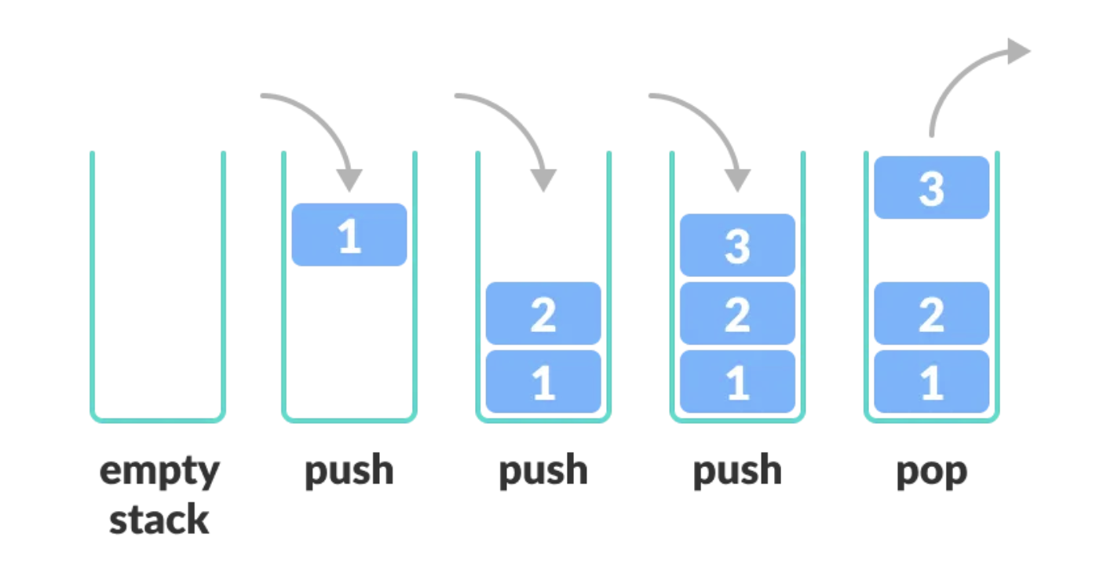
Medium.com

A stack stores items in order, but only the top can be accessed directly. It’s like a waiting line where only the newest person (at the front) can be served first.

Stacks are useful for:
- Organizing data temporarily
- Reversing things (like text or actions)
- Tracking steps (like undo or redo functions)

Common Stack Operations

Method | What it does
isEmpty() | Check if the stack has anything in it.
push() | Adds a new item to the top of the stack.
pop() | Removes the top item from the stack.
peek() | Lets you see the top item without removing it.

Queues - First In First Out (FIFO)

Imagine you’re in a queue at a shop. You join the back of the line, and people at the front get served first. This is how a queue works in computer science — a First In, First Out (FIFO) system. That means:
- The first item added to the queue is the first one to come out.
- The last item added will wait until everything before it has been removed.

A queue stores data in the order it arrives and processes it in the same order, just like a line of people waiting their turn.
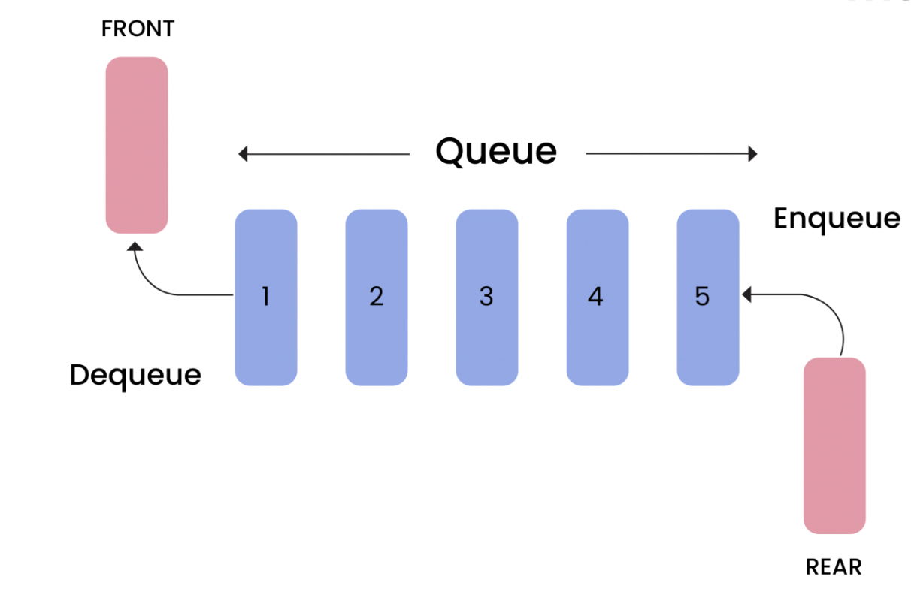
Masaischool.com

Common Queue Operations

Method | What it does
isEmpty() | Checks if the queue has anything in it.
enqueue() | Adds a new item to the back of the queue.
dequeue() | Removes the item at the front of the queue.
front() | Lets you see what’s at the front without removing it.

Week 11 - Intro to OOP
Week 11 - Introduction to OOP

Object-Oriented Programming (OOP) is a way of writing programs that uses objects, things that bundle together both data and the actions that work with that data.

This makes programs easier to understand, reuse, and organize, because each part of the program can be treated like a “real-world object” (for example, a Student, a Book, or a Car).

The four main ideas in Object-Oriented Programming (OOP) are:
- Encapsulation
- Abstraction
- Inheritance
- Polymorphism

Note: According to the IBDP Computer Science Guide:
- Standard Level (SL) students only need to understand OOP concepts using one class.
- However, for the Internal Assessment (IA) and when creating UML diagrams, we will explore multiple classes so that you can clearly see and understand concepts like Inheritance and Polymorphism.

UML (Unified Modeling Language) diagrams help us plan and visualize how a program is structured before writing code. They show:
- Classes and their attributes (data)
- Methods (actions)
- How classes are connected (e.g. inheritance or relationships)

You can think of UML diagrams like a blueprint for a program. They show how different classes are connected and how they work together. They help us see the structure of our code before we start writing it. We’ll explore UML diagrams in more detail as we continue through our lessons.

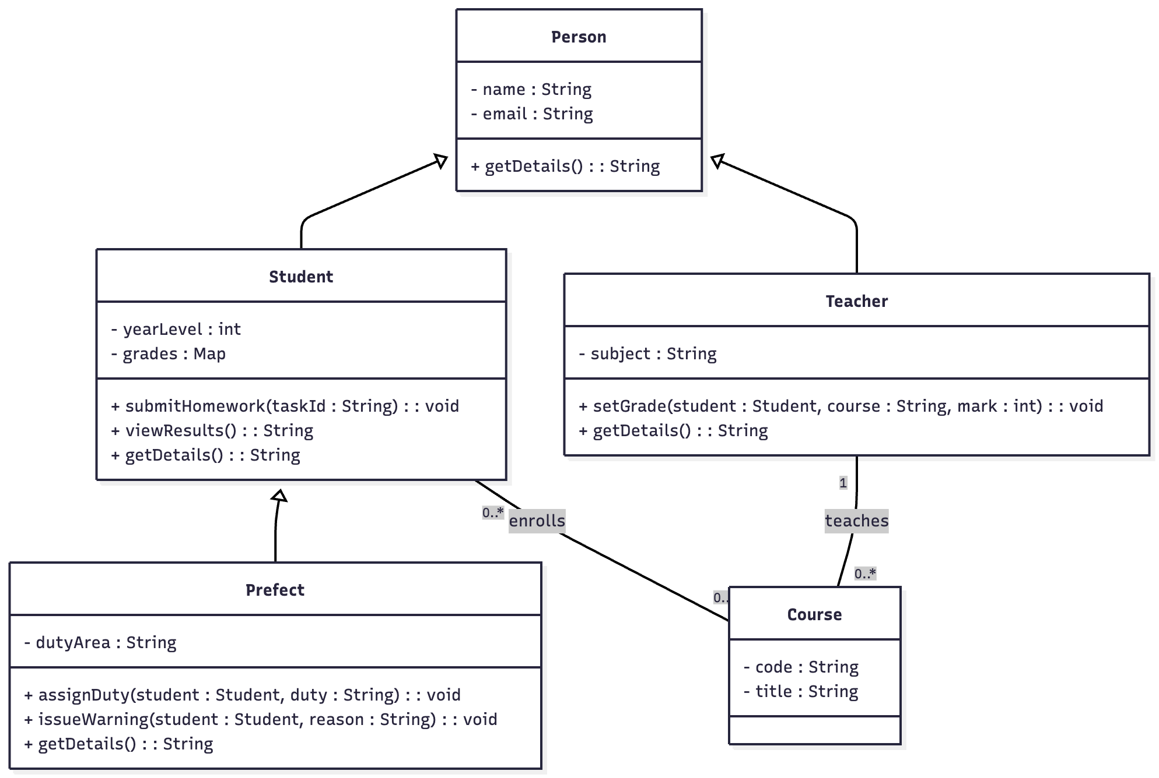
Let’s go over some important terms that will keep coming up as we explore Object-Oriented Programming (OOP).

Term | Simple Explanation
Class | A template or blueprint used to create objects. It defines what data (attributes) and actions (methods) the objects will have.
Object | Something that is created from a class. Each object has its own data and can perform the actions defined in the class.
Encapsulation | Keeping data and the code that works with it together in one place — inside an object. This helps protect and organize information.
Abstraction | Hiding unnecessary details and showing only what’s important. It helps make complex systems easier to understand and use.
Inheritance | Reusing code by creating a new class based on an existing one. The new class “inherits” the attributes and methods of the old class.
Polymorphism | Allowing the same action or method to behave differently depending on which object is using it.

Let’s use a school as an example to make these ideas easier to understand.

Term | Simple Explanation
Class | The Student class is like a blueprint describing what every student should have — a name, year level, and grades — and what they can do, like submit homework or view results.
Object | Each actual student (e.g., Ava, Ben, Chen) is an object created from the Student class. They all share the same structure but have their own data (different names, grades, and subjects).
Encapsulation | A student’s information (name, subjects, grades) is kept safely inside their record. Only specific methods, like updateGrade(), can change it.
Abstraction | The student uses a system to check their results — they see their marks, but they don’t need to know how the grading system calculates the average behind the scenes.
Inheritance | The Prefect class can inherit from the Student class. It has everything a normal student has, plus extra features like assignDuty() or issueWarning().
Polymorphism | Both Student and Teacher classes can have a method called getDetails(), but each version gives different information (a student’s grades vs. a teacher’s subjects taught).

Object-Oriented Programming helps us organize code like a real-world system, in this case, our “school”, where classes define structure, objects represent real things, and the four main ideas (encapsulation, abstraction, inheritance, polymorphism) make our code cleaner, safer, and more flexible.

Object-Oriented Programming helps you write code that’s:
- Organized - grouped into logical classes
- Reusable - avoids repetition
- Flexible - easily extended with inheritance and polymorphism
- Safe - through encapsulation and validation

Let’s make a simple Book class with attributes for title and author, and a method to display its details.

# Define the Animal class
# animal.py
class Animal:
# Constructor Method
def __init__(self, name: str, age: int):
self.__name = name
self.__age = age

# This method returns a readable description of the Animal object showing its name and age.
def __str__(self):
return f"Animal: {self.__name} | Age: {self.__age}"
Explanation:
- name and age are attributes of the animal class.
- __init__() is the constructor, which sets up a new animal object.
- __str__ is a method that shows the animal’s details.

Now let’s create an object (an instance of the class) and call its method. We do this by creating a “Main” function/method. This is also known as our driver class. It drives the execution of your program, instantiates classes, calls methods in the right order, handles basic I/O, and then exits.

# Main.py (driver class)
# Class imported for use
from animal import Animal

# Create an instance/object of the animal class
a1 = Animal("Nala", 4)
a2 = Animal("Simba", 5)

# Call the method to output the details within in object
print(a1.__str__())
print(a2.__str__())
Output:
- Animal: Nala | Age: 4
- Animal: Simba | Age: 5

Encapsulation means keeping an object’s data private and only allowing access through special methods. In Python, we do this by using private attributes (with a _ or __ prefix) and getter/setter methods.

# animal.py
class Animal:
def __init__(self, name, age):
self.__name = name
self.set_age(age) # use setter to validate at creation

# Getter for name
def get_name(self):
return self.__name

# Getter for age
def get_age(self):
return self.__age

# Setter for age
def set_age(self, age):
if age >= 0:
self.__age = age
else:
self.__age = 0
print("Invalid age. Setting age to 0.")

# Method to display info
# Use self. to access an object’s data or methods inside the class.
def __str__(self):
return f"Animal: {self.__name} | Age: {self.__age}"

# Main.py (driver class)
# Class imported for use
from animal import Animal

# Create an instance/object of the Animal class
a1 = Animal("Nala", -1)
a2 = Animal("Simba", 5)

# Call the method
print(a1.__str__())
print(a2.__str__())
print(a1.get_name())
print(a1.get_age())
print(a2.get_name())
print(a2.get_age())
Explanation:
- We use the dot notation with getter and setter methods to safely access and change the values inside an object — without breaking the rules that protect the data.
- Output:
  - Invalid age. Setting age to 0.
  - Animal: Nala | Age: 0
  - Animal: Simba | Age: 5
  - Nala
  - 0
  - Simba
  - 5

Inheritance (extends) means creating a new class that reuses the code from an existing class. In Python, we do this by making one class (called the child or subclass) inherit from another class (called the parent or superclass). This allows the child class to automatically get all the attributes and methods of the parent class, without rewriting them.

# animal.py
class Animal:
def __init__(self, name, age):
self.__name = name
self.set_age(age) # use setter to validate at creation

# Getter for name
def get_name(self):
return self.__name

# Getter for age
def get_age(self):
return self.__age

# Setter for age
def set_age(self, age):
if age >= 0:
self.__age = age
else:
self.__age = 0
print("Invalid age. Setting age to 0.")

# Method to display info
# Use self. to access an object’s data or methods inside the class.
def __str__(self):
return f"Animal: {self.__name} | Age: {self.__age}"

from animal import Animal

class Dog(Animal):
def __init__(self, name, age):
super().__init__(name, age)

def __str__(self):
# use getters because __name/__age are private in Animal
return f"Dog: {self.get_name()} | Age: {self.get_age()}"

# Main.py (driver class)
# Class imported for use
from animal import Animal
from dog import Dog

# Create an instance/object of the Book class
d1 = Dog("Buddy", 3)

# Call the method
print(d1.__str__())
Output:
- Dog: Buddy | Age: 3

Polymorphism means using the same method name or action to work in different ways depending on the object. In Python, we do this by creating multiple classes that share a common method name (like speak() or move()), but each class provides its own version of that method. This allows one function or piece of code to handle different object types in a flexible way, even if those objects behave differently.

In simple words: polymorphism lets different objects respond to the same command in their own way.

# animal.py
class Animal:
def __init__(self, name, age):
self.__name = name
self.set_age(age) # use setter to validate at creation

# Getter for name
def get_name(self):
return self.__name

# Getter for age
def get_age(self):
return self.__age

# Setter for age
def set_age(self, age):
if age >= 0:
self.__age = age
else:
self.__age = 0
print("Invalid age. Setting age to 0.")

# Method to display info
# Use self. to access an object’s data or methods inside the class.
def __str__(self):
return f"Animal: {self.__name} | Age: {self.__age}"

from animal import Animal

class Dog(Animal):
def __init__(self, name, age):
super().__init__(name, age)

def __str__(self):
# use getters because __name/__age are private in Animal
return f"Dog: {self.get_name()} | Age: {self.get_age()}"

# Main.py (driver class)
# Class imported for use
from animal import Animal
from dog import Dog

# Create an instance/object of the Book class
a1 = Animal("Nala", -1)
a2 = Animal("Simba", 5)
d1 = Dog("Buddy", 3)

# Call the method
print(a1.__str__())
print(a2.__str__())
print(d1.__str__())

# Put them in one list
zoo = [a1, a2, d1]
# Polymorphism: the SAME call triggers DIFFERENT __str__ methods
for creature in zoo:
print(creature) # calls creature.__str__() automatically

Explanation:
- When .__str__() is called on a1 (an Animal object), it runs the Animal version of __str__().
- When .__str__() is called on a1 (a Dog object), it runs the Dog version of __str__().
- This is known as method overriding.

This UML diagram shows that Dog inherits from Animal. Animal is the parent class with private attributes (__name, __age) and shared methods for getting, setting, and displaying data. Dog is the child class that reuses these features but overrides the __str__() method, showing polymorphism — the same method name behaves differently in each class.

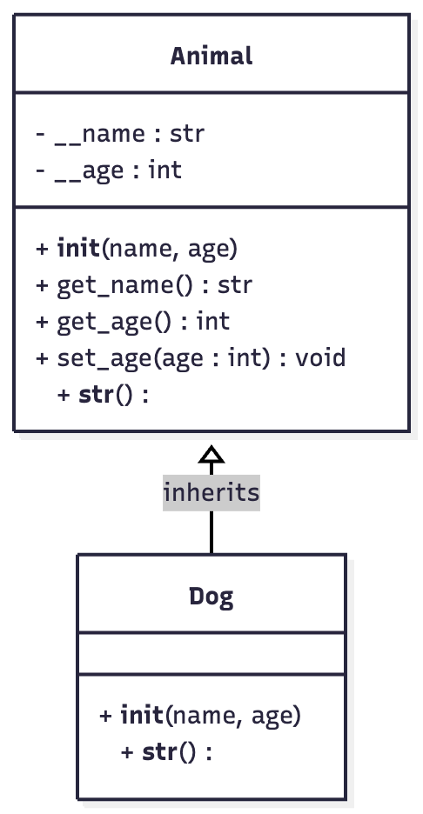

Practice Questions

- Write a Product class that demonstrates Encapsulation by keeping its data private. Include attributes name and price, with getter and setter methods for each. Add a method __str__() to print the product’s details. If the price entered is less than 0, assign 0 as a default value to protect the data.

- Demonstrate Inheritance by creating a subclass Electronics that extends the Product class. Add a new attribute warranty_months with getter and setter methods. If the warranty entered is less than 0, assign 0 as a default value. Use Polymorphism to create a method __str__() to include the warranty details (as well as the details of the products).

- Finally, create objects from both Product and Electronics in a main program and call __str__() on each to show Polymorphism, where the same method name behaves differently depending on the object’s class.

# product.py
class Product:
def __init__(self, name, price):
self.set_name(name)
self.set_price(price) # validate price at creation

# Getter for name
def get_name(self):
return self.__name

# Setter for name
def set_name(self, name):
self.__name = name

# Getter for price
def get_price(self):
return self.__price

# Setter for price (validate non-negative)
def set_price(self, price):
if price >= 0:
self.__price = price
else:
self.__price = 0
print("Invalid price. Setting price to 0.")

# Method to display info
def displayInfo(self):
print(f"Product: {self.__name} | Price: ${self.__price}")

# electronics.py
from product import Product

class Electronics(Product):
def __init__(self, name, price, warranty_months):
super().__init__(name, price)
self.set_warranty_months(warranty_months)

# Getter for warranty_months
def get_warranty_months(self):
return self.__warranty_months

# Setter for warranty_months (validate non-negative)
def set_warranty_months(self, months):
if months >= 0:
self.__warranty_months = months
else:
self.__warranty_months = 0
print("Invalid warranty. Setting months to 0.")

# Override displayInfo to include warranty
def displayInfo(self):
# use getters because parent attributes are private
print(f"Electronics: {self.get_name()} | Price: ${self.get_price()} | Warranty: {self.__warranty_months} months")

# main.py
from product import Product
from electronics import Electronics

# Create objects
p1 = Product("Notebook", -3) # will reset price to 0 (validation)
p2 = Product("Backpack", 39)
e1 = Electronics("Headphones", 79, 12)

# Polymorphism: same call, different outputs based on class
items = [p1, p2, e1]
for item in items:
item.displayInfo()


Week 12 - Encapsulation
Week 12 - Encapsulation

Encapsulation means keeping all the information about an object together inside a class. It helps to protect the data and makes the program easier to manage and understand. Think of a vending machine:
- You press buttons (methods) to get snacks.
- You don’t open the machine and grab items directly (data protection).

Encapsulation works the same way, you interact through methods, not directly with the object’s data.

Why it’s important:
- Keeps the data safe and private.
- Prevents accidental changes to important variables.
- Makes code easier to debug, update, and reuse.
- Only allows changes to data through controlled methods (getters and setters).
  - Getter (accessor) → reads or “gets” the value of a private variable.
  - Setter (mutator) → changes or “sets” the value safely.
Different programming languages (like Java) use access modifiers to control visibility. Python uses naming conventions instead.
Access Type | Meaning | Example
Public | Can be accessed from anywhere | self.name
Protected | Should not be accessed outside the class (by convention) | self._age
Private | Hidden from outside the class (name-mangled) | self.__age
Default | Accessible within the same package (package-private) | Python has no direct equivalent, all members are technically public unless prefixed

In the following example, we are going to create a TransitCard class that encapsulates the account holder’s name, balance and card number:
- Private attributes (__holder, __card_no, __balance) protect the internal state.
- Getters give read-only access.
- Mutators (top_up, tap_fare) validate changes (no negative top-ups, no overdrafts, i.e. balance cannot be less than 0).
- __str__() gives a clean, single-line summary for print(card).

# transit_card.py
class TransitCard:
"""
Encapsulated TransitCard:
- Private attributes: __holder, __card_no, __balance
- Getters provide read-only access
- Methods top_up() and tap_fare() validate and modify balance safely
- __str__() returns a friendly string for printing
"""
def __init__(self, holder, card_no, balance=0.0):
self.__holder = holder
self.__card_no = card_no
self.__balance = 0.0
self.top_up(balance) # validate initial balance

# getters (read-only access)
def get_holder(self):
return self.__holder

def get_card_no(self):
return self.__card_no

def get_balance(self):
return self.__balance

# controlled updates
def top_up(self, amount):
if amount > 0:
self.__balance += amount
return True
print("Top-up failed: amount must be positive.")
return False

def tap_fare(self, fare):
if fare <= 0:
print("Fare must be positive.")
return False
if fare > self.__balance:
print("Insufficient funds.")
return False
self.__balance -= fare
return True

def __str__(self):
return "TransitCard(holder=" + self.__holder + \
", card=" + self.__card_no + \
", balance=" + f"{self.__balance:.2f}" + ")"

# main.py
from transit_card import TransitCard

# Create a TransitCard object
card = TransitCard("Ava", "EZ-123-456", 15.0)

# Access details via getters (read-only)
print(card) # uses __str__()
print("Holder:", card.get_holder())
print("Card No.:", card.get_card_no())
print("Initial Balance:", card.get_balance())

# Top up safely
card.top_up(10.0)
print("After top-up:", card.get_balance()) # 25.0

# Tap fare with validation
ok = card.tap_fare(3.5)
if ok:
print("After fare:", card.get_balance()) # 21.5

# Invalid operations (won't corrupt state)
card.top_up(-5) # rejected
card.tap_fare(1_000) # rejected (insufficient funds)

print(card.__str__())

Output:
- TransitCard(holder=Ava, card=EZ-123-456, balance=15.00)
- Holder: Ava
- Card No.: EZ-123-456
- Initial Balance: 15.0
- After top-up: 25.0
- After fare: 21.5
- Top-up failed: amount must be positive.
- Insufficient funds.
- TransitCard(holder=Ava, card=EZ-123-456, balance=21.50)

What happens if you modify attributes within a class directly without encapsulation? Let’s put it this way, it is highly recommended that you don’t! Why?

Let’s look at an example where all attributes are public and can be modified directly, potentially leading to unexpected or invalid states.

# transit_card.py
class TransitCardPublic:
# Everything is public (NOT recommended)
def __init__(self, holder, card_no, balance=0.0):
self.holder = holder
self.card_no = card_no
self.balance = balance

def __str__(self):
return "TransitCardPublic(holder=" + str(self.holder) + \
", card=" + str(self.card_no) + \
", balance=" + str(self.balance) + ")"

# main.py
from transit_card_public import TransitCardPublic

card = TransitCardPublic("Ben", "EZ-999-000", 20.0)
print("Initial:", card)

# --- Direct, unsafe edits (no validation) ---
card.balance = -500.0 # ❌ negative balance now “allowed”
card.card_no = "" # ❌ empty card number
card.holder = None # ❌ holder removed
print("After unsafe edits:", card.__str__())

card.balance = "ten" # ❌ string in a numeric field

# Somewhere else in the program…
def charge(card_obj, fare):
# This will crash at runtime if balance isn’t numeric
card_obj.balance = card_obj.balance - fare

Why is this a bad method of implementation?
- No validation → Impossible states like negative balances or empty card numbers.
- Type mistakes sneak in → a string replaces a number and you only find out later (runtime crash).
- Scattered logic → Any part of the codebase can change balance differently; rules aren’t centralized.
- Hard to maintain → If the business rule changes (e.g., minimum balance), you must fix it everywhere it’s used.
- No audit trail → You can’t intercept changes to log or enforce limits.

Checklist:
- Can code outside the class assign any value directly to important fields?
- Are there no checks for invalid values (negative, empty, wrong type)?
- Do multiple places in the application modify the same field in different ways?

If you answer “yes” to any of these, you’re looking at a lack of encapsulation.

Practice Questions

- Create an Athlete class with private attributes name, age, and rating. Write getters and setters for each attribute. Validate age in the setter so it cannot be negative (if invalid, set to 0 and print a message). Create two objects and print them using __str__().

# athelete class
class Athlete:
def __init__(self, name, age, rating):
self.__name = name
self.__rating = rating
self.set_age(age) # validate via setter

# getters (read-only access from outside)
def get_name(self):
return self.__name

def get_age(self):
return self.__age

def get_rating(self):
return self.__rating

# setters (controlled updates)
def set_name(self, name):
self.__name = name

def set_age(self, age):
if age >= 0:
self.__age = age
else:
self.__age = 0
print("Invalid age. Setting age to 0.")

def set_rating(self, rating):
self.__rating = rating

def __str__(self):
return f"Athlete(name={self.__name}, age={self.__age}, rating={self.__rating})"

# main class
from athelete import Athlete
a1 = Athlete("Ava Lee", -3, "Intermediate") # age validated to 0
a2 = Athlete("Ben Chan", 17, "Advanced")

print(a1.__str__())
print(a2.__str__())

a1.set_age(16)
a1.set_rating("Advanced")
print("After updates:", a1.__str__())


- Create a Product class with private attributes name, brand, and a 13 digit number. Write getters for all attributes and a setter for ean13 that only accepts a 13-digit numeric string (else set a default placeholder and print a warning). Create two products and show the output using __str__(). Make use of the isinstance(variable, data type), len() and isdigit() functions to verify a 13 digit number has been entered correctly.

# ---------- product.py ----------
class Product:
def __init__(self, name, brand, number13):
self.__name = name
self.__brand = brand
self.set_number13(number13) # validate via setter

# getters
def get_name(self):
return self.__name

def get_brand(self):
return self.__brand

def get_number13(self):
return self.__number13

# setter with validation (13 numeric characters)
def set_number13(self, code):
if isinstance(code, str) and len(code) == 13 and code.isdigit():
self.__number13 = code
else:
self.__number13 = "0000000000000"
print("Invalid 13-digit number. Setting default placeholder.")

def __str__(self):
return f"Product(name={self.__name}, brand={self.__brand}, number13={self.__number13})"

# main.py
from product import Product
p1 = Product("Wireless Mouse", "SwiftTech", "8881234567890")
p2 = Product("USB-C Cable", "Voltix", "12345") # invalid → placeholder

print(p1.__str__())
print(p2.__str__())

p2.set_number13("9781861972712") # valid update
print("After update:", p2.__str__())


- Create a Freelancer class with private attributes name and salary. Write getters/setters, ensuring salary never goes below 7000. Add a method raiseSalary(percent) that increases the salary by a given percentage. Write a menu program with options:
1.) Create new freelancer
2.) Increase Salary
3) View Freelancer Details
4) Exit

Assume only one freelancer exists.

# ---------- freelancer.py ----------
class Freelancer:
# Class/Static variable, This means it belongs to the class itself, not to individual objects.
MIN_WAGE = 7000

def __init__(self, name, salary):
self.__name = name # instance variable (unique per object)
self.set_salary(salary) # enforce min wage

# getters
def get_name(self):
return self.__name

def get_salary(self):
return self.__salary

# setters / actions
def set_name(self, name):
self.__name = name

def set_salary(self, salary):
if salary < Freelancer.MIN_WAGE:
self.__salary = Freelancer.MIN_WAGE
print("Salary below minimum. Setting to", Freelancer.MIN_WAGE)
else:
self.__salary = salary

def raiseSalary(self, percent):
try:
p = float(percent) # convert input to number
except ValueError:
print("Invalid percentage.")
return False

self.__salary *= (1 + p / 100) # apply raise (e.g., 5 → +5%)

# never go below minimum wage
if self.__salary < Freelancer.MIN_WAGE:
self.__salary = Freelancer.MIN_WAGE
return True

def __str__(self):
return f"Freelancer(name={self.__name}, salary={self.__salary:.2f})"

# ---------- main menu (single freelancer) ----------
from freelancer import Freelancer
def main():
worker = None # only one freelancer assumed

while True:
print("\n--- Freelancer Menu ---")
print("1) Create new freelancer")
print("2) Increase Salary")
print("3) View Freelancer Details")
print("4) Exit")

choice = input("Enter choice (1-4): ").strip()

if choice == "1":
name = input("Enter name: ").strip()
try:
salary = float(input("Enter starting salary: ").strip())
except:
salary = Freelancer.MIN_WAGE
print("Invalid salary. Using minimum wage.")
worker = Freelancer(name, salary)
print("Created:", worker.__str__())

elif choice == "2":
if worker is None:
print("No freelancer created yet.")
continue
percent = input("Enter raise percentage (e.g., 5 for 5%): ").strip()
if worker.raiseSalary(percent):
print("Salary updated.")
print(worker.__str__())

elif choice == "3":
if worker is None:
print("No freelancer created yet.")
else:
print(worker.__str__())

elif choice == "4":
print("Goodbye.")
break
else:
print("Invalid option. Try again.")

# Only run main() when this file is executed directly, not when it’s imported by another file
if __name__ == "__main__":
main()


Week 13 - Polymorphism
Week 13 - Polymorphism

Polymorphism is one of the key ideas in Object-Oriented Programming (OOP). It means that the same method name can behave differently depending on the object that uses it. This makes code more flexible, easier to extend, and less repetitive. In simple terms, “Same action, different behavior depending on the object.”

Why It’s Useful:
- Makes code reusable — the same method name can be used across related classes.
- Makes programs easier to update — if new object types are added, they can still use the same method names.
- Makes programs cleaner and easier to understand — no need for lots of if-statements checking types.

Type | Meaning | Example
Method Overloading | Having several methods with the same name but different parameters in one class. | Python doesn’t directly support this like Java, but you can simulate it using default or optional parameters.
Constructor Overloading | Having multiple constructors so objects can be created in different ways. | Python usually does this through optional parameters in __init__().
Method Overriding | When a subclass replaces a method from its parent class with its own version. | This is the most common in Python — for example, redefining __str__() in each subclass to display information differently.

Summary:
- Polymorphism literally means “many forms.”
- It allows the same method name (like __str__()) to behave differently depending on the object.
- It’s especially useful with inheritance — subclasses can override parent methods to fit their behavior.
- This makes code more readable, adaptable, and object-focused — a key idea in OOP.

Constructor Overloading

Constructor overloading allows you to create objects in different ways, depending on how much information you have. In Java, this is done by writing multiple constructors with different parameters. Python doesn’t allow more than one __init__() method, but we can achieve the same idea using class methods (@classmethod).

Why It’s Useful:
- It gives flexibility when creating objects.
- You can use different sets of data to initialise an object.
- You avoid duplicating code by reusing the main constructor (__init__).

# animal class
class Animal:
def __init__(self, name, age):
# This is the main constructor.
# It runs every time an Animal object is created.
self.__name = name
self.__age = age

@classmethod
def from_name(cls, name):
# This is an ALTERNATIVE constructor.
# It creates an Animal with only the name provided.
# The age defaults to 0.
return cls(name, 0) # calls __init__(name, 0)

@classmethod
def from_name_and_age(cls, name, age):
# Another alternative constructor.
# It creates an Animal using both name and age.
return cls(name, age) # calls __init__(name, age)

def __str__(self):
# Defines what prints when you use print(object)
return f"Animal: {self.__name} | Age: {self.__age}"

# main.py
from animal import Animal

# --- Create objects in two different ways ---
a1 = Animal.from_name("Nala") # Only name provided
a2 = Animal.from_name_and_age("Simba", 5) # Both name and age provided

# --- Print both objects ---
print(a1.__str__()) # Animal: Nala | Age: 0
print(a2.__str__()) # Animal: Simba | Age: 5

Output:
- Animal: Nala | Age: 0
- Animal: Simba | Age: 5

Method Overriding

Method overriding happens when a subclass (child class) provides its own version of a method that already exists in the superclass (parent class). In simple terms: The child keeps the same method name, but changes what it does. This allows different classes to behave differently when the same method is called, a key part of polymorphism.

Why It’s Useful:
- It allows subclasses to specialise or extend the behaviour of the parent class.
- It avoids rewriting all code from scratch — the child can reuse and modify only what it needs.
- It makes your program more flexible and object-oriented.

# animal class
class Animal:
def __init__(self, name, age):
# Constructor for Animal objects
self.__name = name
self.set_age(age)

# Getters (for accessing private attributes)
def get_name(self):
return self.__name

def get_age(self):
return self.__age

# Setter with validation
def set_age(self, age):
if age >= 0:
self.__age = age
else:
self.__age = 0
print("Invalid age. Setting age to 0.")

# Method to describe the animal
def __str__(self):
return f"Animal: {self.__name} | Age: {self.__age}"

# --- Subclass Dog inherits from Animal ---
# Inheritance
class Dog(Animal):
def __init__(self, name, age):
# Call the parent class constructor to reuse setup
super().__init__(name, age)

# Override __str__() to change how a Dog is described
def __str__(self):
# Access private attributes via getters
return f"Dog: {self.get_name()} | Age: {self.get_age()}"

# --- Main Program (demonstrating overriding) ---
a1 = Animal("Nala", 4)
d1 = Dog("Buddy", 3)

# Same method name (__str__), different behaviour
print(a1.__str__()) # Calls Animal.__str__()
print(d1.__str__()) # Calls Dog.__str__()

# Polymorphism: same call, different output
zoo = [a1, d1]
for creature in zoo:
print(creature.__str__()) # Automatically calls the right __str__()


Output:
- Animal: Nala | Age: 4
- Dog: Buddy | Age: 3
- Animal: Nala | Age: 4
- Dog: Buddy | Age: 3

Practice Questions

- Constructor Overloading - Write a GameCharacter class that can be created in two ways:
- With only a name (default level = 1)
- With both name and level (user-defined)

Use class methods to simulate constructor overloading. Include validation so that level cannot be less than 1. Make use of the isinstance(variable, data type) to verify and integer has been entered.

# ---------- game_character.py ----------
class GameCharacter:
"""
Demonstrates constructor overloading (Python-style):
- __init__(name, level): main constructor
- from_name(name): acts like a 1-arg constructor
- from_name_and_level(name, level): acts like a 2-arg constructor
"""

def __init__(self, name, level):
# Private attributes (encapsulation)
self.__name = name
self.set_level(level) # validation using setter

# --- Simulated Overloaded Constructors ---
@classmethod
def from_name(cls, name):
"""Alternative constructor: default level = 1"""
return cls(name, 1)

@classmethod
def from_name_and_level(cls, name, level):
"""Alternative constructor: custom level"""
return cls(name, level)

# --- Getter and Setter Methods ---
def get_name(self):
return self.__name

def get_level(self):
return self.__level

def set_level(self, level):
# Validate level input
if isinstance(level, int) and level >= 1:
self.__level = level
else:
self.__level = 1
print("Invalid level. Setting level to 1.")

# --- Display Info ---
def __str__(self):
return f"GameCharacter(name={self.__name}, level={self.__level})"

# ---------- main.py ----------
from game_character import GameCharacter
c1 = GameCharacter.from_name("Astra") # uses 1-arg constructor
c2 = GameCharacter.from_name_and_level("Riven", 7) # uses 2-arg constructor

print(c1.__str__())
print(c2.__str__())


- Method Overriding - Create a Vehicle superclass (parent class) with a method move() that prints “moves in a general way.”
Then, create two subclasses:
- Car → overrides move() to print “drives on the road”
- Boat → overrides move() to print “sails on the water”

Demonstrate polymorphism by calling the same method (move) on different object types.

# ---------- vehicle_override.py ----------

class Vehicle:
"""
Superclass: has a generic move() method.
Subclasses override move() to behave differently.
"""

def __init__(self, name):
self.__name = name # private attribute (encapsulation)

def get_name(self):
return self.__name

def move(self):
"""General behaviour"""
return f"{self.__name} moves in a general way."

def __str__(self):
return f"Vehicle(name={self.__name})"

# --- Subclass Boat ---
from vehicle_override import Vehicle
class Boat(Vehicle):
def __init__(self, name):
super().__init__(name)

# Override move() to provide specific behaviour
def move(self):
return f"{self.get_name()} sails on the water."

# --- Subclass Car ---
from vehicle_override import Vehicle

class Car(Vehicle):
def __init__(self, name):
super().__init__(name)

# Override move() to provide specific behaviour
def move(self):
return f"{self.get_name()} drives on the road."

# ---------- main.py ----------
from vehicle_override import Vehicle
from boat import Boat
from car import Car

v1 = Vehicle("Transport")
c1 = Car("Sedan")
b1 = Boat("Ferry")

print(v1.move()) # Parent version
print(c1.move()) # Overridden in Car
print(b1.move()) # Overridden in Boat

# Demonstrating polymorphism
fleet = [v1, c1, b1]
for vehicle in fleet:
print(vehicle.move())


